Calculus 1 Lecture 3.4: The Second Derivative Test for Concavity of Functions f

Recall:
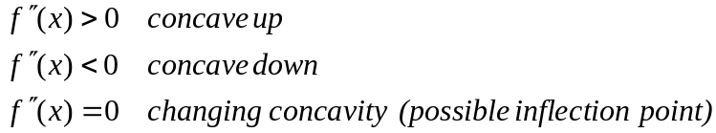

Now to find inflection points (use the second derivative test)
- take the second derivative.
- Set the second derivative to zero and solve ( gives potential inflection points)
- Make a table
- Find the sign of each interval by using 2nd derivative formula

Example
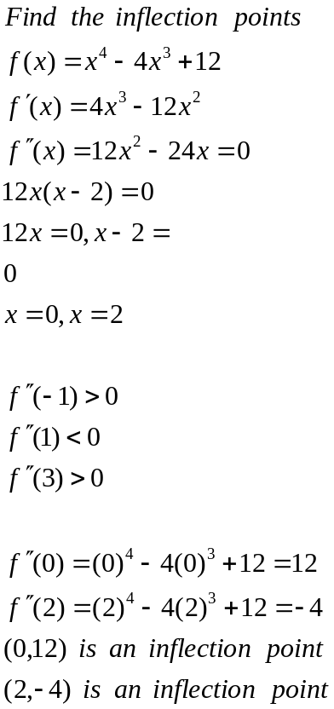

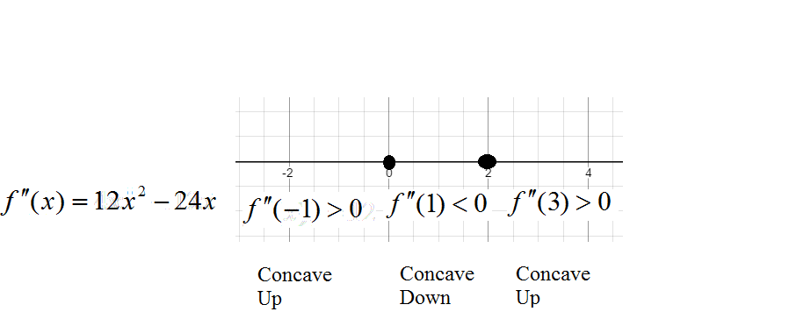
When signs change between intervals then it is an inflection point.

Example
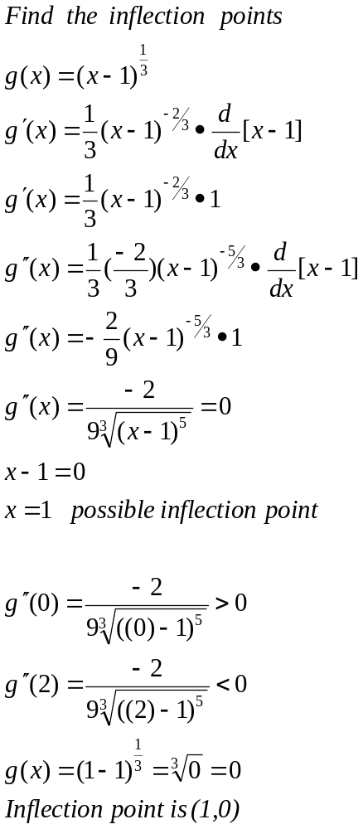
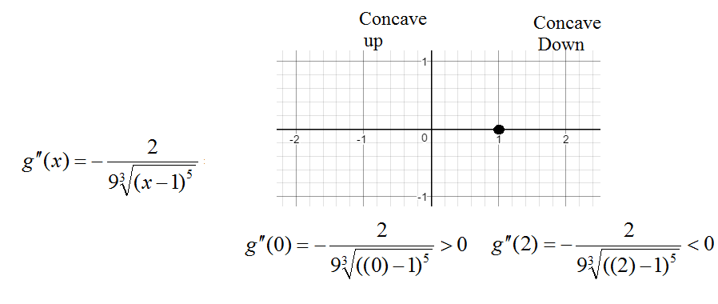

Example
